Fast**National University of Computer & Emerging Sciences, Karachi  
Fall-2020 CS-Department  
Assignment 2**

**Deadline 16 March 2020 2:30 pm – 3:30 pm**

|  |  |
| --- | --- |
| **Course Code: CS301** | **Course Name: Theory of Automata** |

**Question 1:**

**10 points**

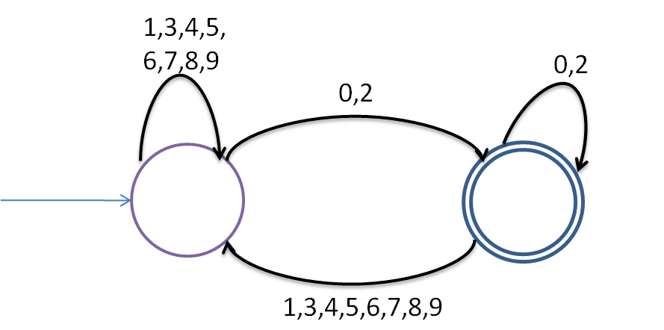

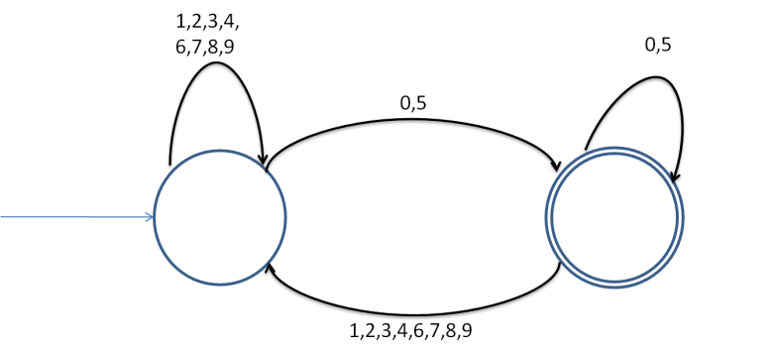

p0

p1

DFA2: Divisible by 2

q0

q1

DFA1: Divisible by 5

1. **Given two DFA's DFA1 and DFA2 find the intersection DFA1∩ DFA2 to find** **DFA10. What language does DFA 10 accepts?**
2. **Minimize DFA10.**

Question no:1

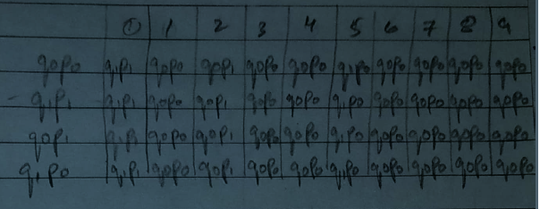

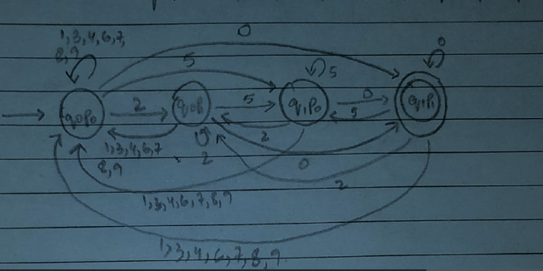

b. 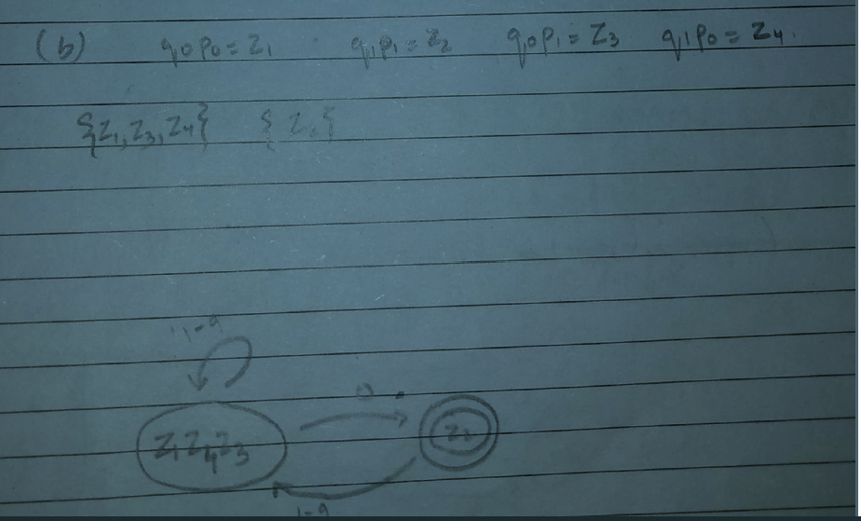

**Question 2: 10 Points**

**Find the minimal DFA of the following.**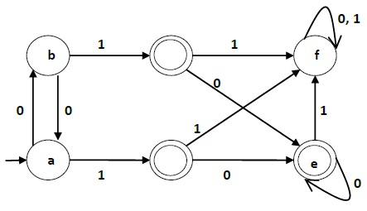

**Solution**

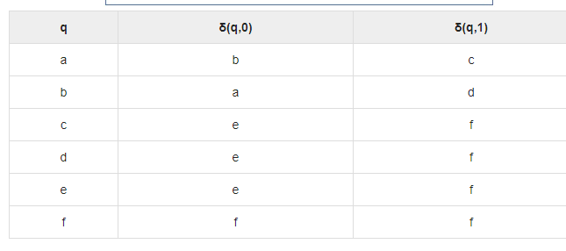

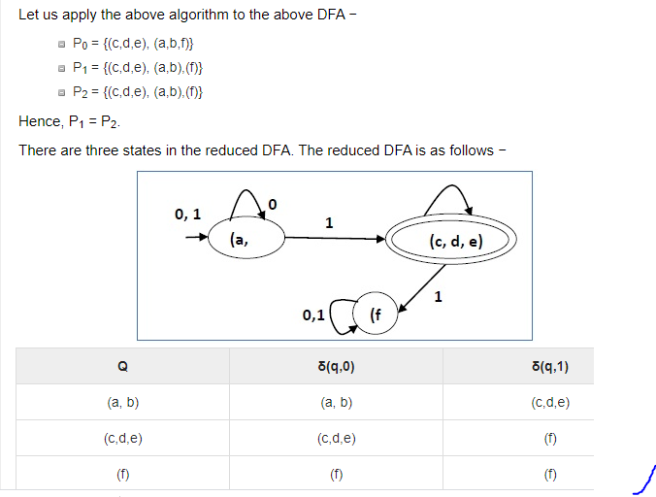

**Note: YOU CAN USE THIS LINK ALSO FOR SOLUTION**

<https://www.tutorialspoint.com/automata_theory/dfa_minimization.htm>

**Question 3**

**Property of regular expression**

**Take any two regular expression of any language draw their NFA and show me properties of regular expression.**

**Ex**

* **union of two NFA or l1 or l2**
* **Concatenation of two NFA**
* **Star OF Language**
* **Reversal of language**
* **complement of language**

***BEST OF LUCK!***